

Dalian, People’s Republic of China 10-12 September 2009

“Summer Davos” in Asia Relaunching Growth

Annual Meeting
of the New Champions 2009

Final List of
IAP Young Scientists
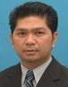 |  | Abdul Rahman  Mohd Basyaruddin  Director  Malaysia Genome Institute, Malaysia
Young Scientist | MY +60 38/926 7446  +60 38/926 7972 (fax)  basya@mosti.gov.my  www.genome.ukm.my
A network-based non-profit research organization researching tropical bioresources through projects on genome sequencing, comparative and functional genomics, and structural biology. Its research programme uses a balanced approach of technology and market-driven innovation adopted in the National Innovation Model.
Personal: BSc in Chemistry and Computer Science with Education, Universiti Teknologi Malaysia; PhD in Catalysis Chemistry, University of Southampton, UK. Formerly, Quality Control Engineer, Sony. With, Malaysia Genome Institute and Universiti Putra Malaysia: Director, Structural Biology Research Center and Head, Chemistry Department; Professor; heads over 10 research projects. Reviewer: Journal of Molecular Catalysis B: Enzymatic; Catalysis Today; Process Biochemistry. Chairman and member of committees for international and national conferences and workshops. Author of papers, book chapters and patents. Recipient of awards.
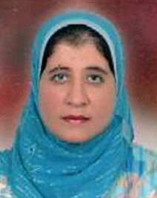 |  | Amin  Amal  Researcher  National Research Center, Egypt
Young Scientist | EG +20 2/3333 5997 ext 2889  +20 2/3337 0931 (fax)  aamin_07@yahoo.com
One of the largest main governmental research centres in the Middle East. It comprises thousands of scientists has complete infrastructure for basic and advanced research.
Personal: 1991, BSc, Chemistry Department, Faculty of Science, Ain Shams University, Cairo; 1997, MSc in Organic Chemistry on preparation and studying of physical and chemical properties of some polymers obtained from some aromatic amine derivatives; 2003, PhD in Organic Chemistry on polymer technology and catalysis, Faculty of Science, Cairo University. Since December 2008, Associate Professor, Polymers and Pigments Department, NRC, Dokki, Cairo; since 2009, post-doctoral Fellowship, Centre for Molecular Design and Recognition, University of Akron, US; leader, Nanostructured Polymers Research Group, NRC, Egypt.
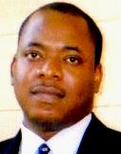 |  | Asaolu  Olumuyiwa  Senior Lecturer  University of Lagos, Nigeria
Young Scientist | NG +234 80/5131 7924  +234 124/8869 6523 (fax)  asaolu@yahoo.com  www.unilag.edu.ng
One of the foremost tertiary institutions in Nigeria. It has produced numerous international scholars, researchers and industry leaders.
Personal: With University of Lagos: 1991, BSc in Civil Engineering; 1995, MSc in Engineering Analysis; 1992, first person to earn PhD in Engineering Analysis from Nigerian university. 2002, national service with Army Engineers; 2003-05, postdoctoral studies and Lecturer, Industrial and Information Engineering Department, University of Tennessee. Currently, Senior Lecturer in Systems Engineering, University of Lagos: research interests, expertise and publications include mathematical and engineering modelling, artificial intelligence, information technology and project management; 2008, named Faculty Best Researcher. Member: Nigerian Computer Society; Institute of Industrial Engineers, US; Associate Fellow, Institute for Operations Research, Nigeria. Interests: reading, chess and music.
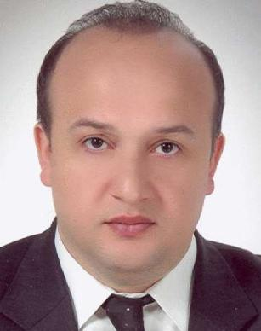 |  | Baykasoglu  Adil  Professor of Industrial Engineering  University of Gaziantep, Turkey
Young Scientist | TR +90 03/423172616  +90 03/423604383 (fax)  baykasoglu@gantep.edu.tr
An institution founded as a state university 1987. Higher education on the campus started in 1973 when the institute was an extension campus of the Middle East Technical University. The main campus is located at Gaziantep with extension campuses situated in the neighbouring cities and districts of Adiyaman, Kilis, Nizip, Oguzeli, Besni and Gölbasi.
Personal: 1993, BSc and, 1995, MSc in Mechanical Engineering; 1999, PhD in Manufacturing Engineering and Operations Management, University of Nottingham. 1993-96, Research Assistant, then Instructor, Department of Mechanical Engineering and Industrial Engineering, University of Gaziantep. Member of the board, several academic journals. Author of 250 academic papers and three books. Editor, several conference books on operational research, computational intelligence, meta-heuristics, quality, and manufacturing systems design. Referee for scientific journals.
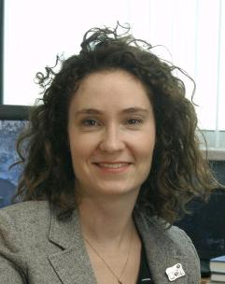 |  | Beaudry  Catherine  Associate Professor  École Polytechnique de Montréal, Canada
Young Scientist | CA +1 514/340 4711 ext 3357  +1 514/340 4173 (fax)  catherine.beaudry@polymtl.ca  www.polymtl.ca
One of Canada's leading engineering schools and the largest in Québec in terms of its student population and the scope of its research activities. Founded in 1873, it has always provided high-quality university instruction in engineering at all levels by focusing on human values and striving to meet the needs of industry and society. It offers a wide array of over 100 programmes at every level, including certificates, Bachelor's, Master's and Doctorate degrees.
Personal: Degree in Electrical Engineering; MPhil and PhD in Economics, University of Oxford; Rhodes Scholar. Currently: Associate Professor, Mathematics and Industrial Engineering Department, École Polytechnique de Montréal; Adjunct Professor, Université du Québec, Montréal. Member, Centre for Interuniversity Research on Science and Technology. Researcher, CIRANO. Current research on impact of university funded research in biotechnology and nanotechnology and the mapping of knowledge proximity in nanomedicine and nanobiotechnology. Research interests: analysis of industrial clusters, collaboration, partnerships and alliances, innovation networks, innovative firm performance and survival.
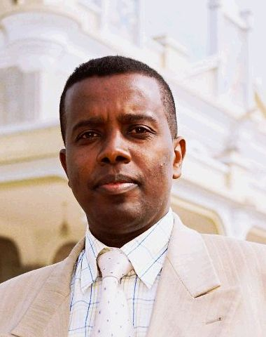 |  | Beyene  Negussie  Researcher  Sua-Apopo Project, Sokoine University of Agriculture, Tanzania
Young Scientist | ET +255 783/139 544  negbene@yahoo.com  www.apopo.org
Sokoine University of Agriculture hosts APOPO's project in its premises through the department of pest management.
Personal: 1991, BSc in Chemistry and 1996, MSc in Analytical Chemistry, Addis Ababa University; 2003, PhD in Analytical Chemistry, Karl-Franzens University, Graz, Austria; 2003-05, postdoctoral fellow, University of Pretoria, South Africa; 2005, senior postdoctoral fellow, Department of Chemical Engineering, URV, Tarragona, Spain. 1992-97, Clinical Chemist and Head, Regional Health Research Laboratory, Ethiopia; 1998-99, Lecturer in Clinical Chemistry, Ethiopia; 2006-07, Assistant Professor, Ethiopia; since 2007, Consultant Analytical Chemist, GICHD-SUA-APOPO, Tanzania. Member, Chemical Society of Ethiopia. Young Affiliate Fellow, TWAS. Reviewer, South African Journal of Chemistry. Expertise: clinical chemistry, environmental chemistry, pharmaceutical analysis, food chemistry, sensors and biosensors, instrumental analysis and emerging nanobiotechnology.

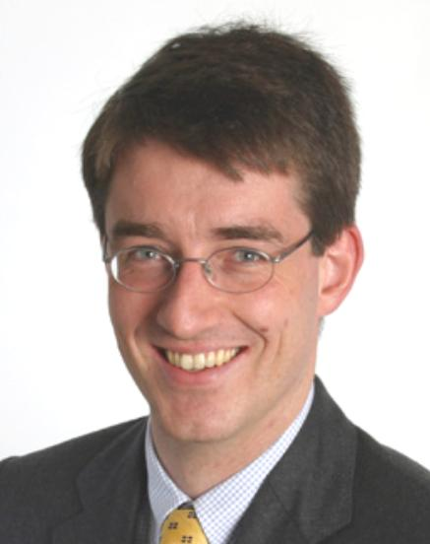 |  | Brück  Tilman  Head, Department of International Economics  German Institute for Economic Research (DIW Berlin), Germany
Young Scientist | DE +49 30/89789 108  +49 30/89789 200 (fax)  tbrueck@diw.de  www.diw.de
One of the leading research institutes in Germany. It is an independent, non-profit academic institution, which is involved, in basic research and policy advice. Its work is determined by three interlinked, international themes important to the German and European economy of accelerating globalization, deepening regional integration and the global differences in income and wealth.
Personal: Studies in Economics, Glasgow University; PhD in Economics, Oxford University. Research and policy interests include poverty reduction, conflict and reconstruction, economic reforms and public policy. Formerly, Consultant for: European Commission; DFID; GTZ; ILO; KfW; OECD; UNDP; USAID. Currently, also Assistant Professor of Development Economics, Humboldt University, Berlin. Founder and Co-Director, Households in Conflict Network. Coordinator, Network for the Economic Analysis of Terrorism. Research Affiliate: Poverty Research Unit, Sussex; Brooks World Poverty Institute, University of Manchester. Fellow: Institute for the Study of Labour, Bonn; German Young Academy of Sciences.
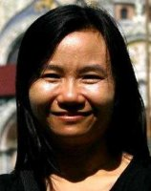 | Chaiyen  Pimchai  Associate Professor  Dept. of Biochemistry /  Center for Excellence in Protein Structure and Function, Mahidol University, Thailand

Young Scientist | Phone: (+66 8) 9669 5410  Fax: (+66 2) 354 7174
One of the most prestigious universities in Thailand. See : www.sc.mahidol.ac.th

Personal: 1992, BSc (Hons) in Chemistry, Prince of Songkla University, Thailand; 1997, PhD in Biological Chemistry, University of Michigan. With Department of Biochemistry, Faculty of Science, Mahidol University, Bangkok: 1997-2001, Lecturer; 2001-05, Assistant Professor; since 2005, current position and Deputy Chair. 2008, Affiliate Fellow, Academy of Sciences for the Developing World. Recipient of awards: L'oreal-Unesco Fellowship for Woman in Science in Thailand (2003); Young Scientist Award, Foundation for the Promotion of Science and Technology under Patronage of King of Thailand (2005); BMB Award, Section of Biochemistry and Molecular Biology, Science Society of Thailand (2009); Faculty of Science Outstanding Lecturer Award (2009). Expertise: Biochemistry, research in enzyme mechanisms.

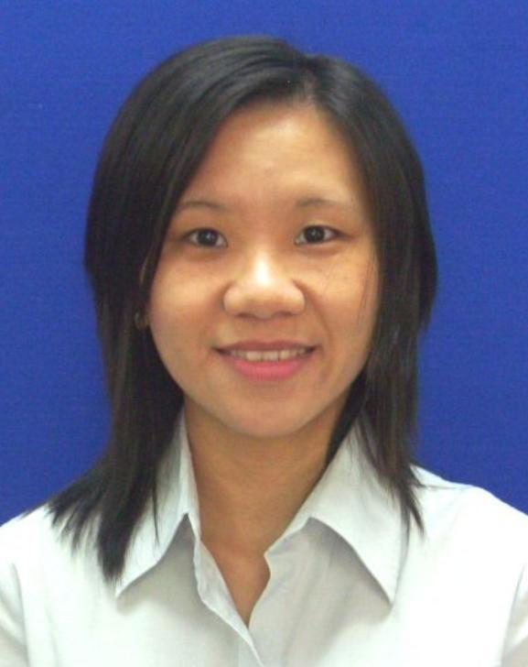 |  | Chan Yoke-Fun  Lecturer  University of Malaya, Malaysia
Young Scientist | MY +60 3/7967 6677  +60 3/7967 5753 (fax)  chanyf@um.edu.my  www.um.edu.my
A research university in Malaysia with more than 27,000 students, 1,700 academic staff and 17 faculties and research centres that cover the arts, sciences and humanities. It began at a Kuala Lumpur campus in 1959 and has an alumni of over 100,000 people. It confers degrees at the Bachelors, Masters and PhD levels and its researchers are in collaborative partnerships with more than 100 international institutions working on topics ranging from HIV-AIDS, infectious diseases, biodiversity and nanotechnology to law, intellectual property, culture, religion, gender studies and poverty eradication studies.
Personal: 2006, PhD in Medical Sciences, University of Malaya, Malaysia. With University of Malaya: supervising three postgraduate students and lectures full time; research interests include molecular epidemiology and pathogenesis of human viruses; 2007, represented Malaysia in 57th Meeting of Nobel Prize Winners with Young Winners in Lindau, Germany; 2007, Novartis Biotechnology Leadership Camp, Japan, where her team won first runner-up for the best business proposal. Author in journals on infectious diseases.
Spouse's Name: Foh Meng-Wha

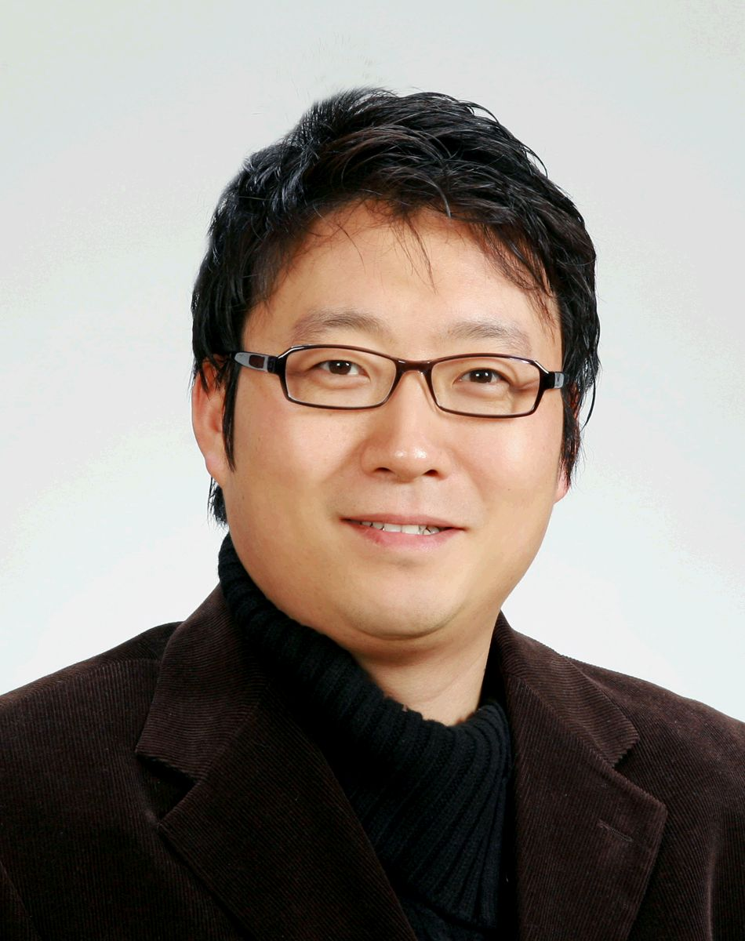 |  | Choi Hee Cheul  Associate Professor  Postech, Department of Chemistry, Division of Advanced Materials, Republic of Korea
Young Scientist | KR +82 54/279 2130  +82 54/279 3399 (fax)  choihc@postech.edu  www.postech.ac.kr/e
Personal : 1994, BSc and 1996, MSc in Applied Chemistry, Kyungpook National University in 1994 and 1996, respectively; PhD in Chemistry, Purdue University. Formerly, postdoctoral Research Associate, Stanford University, studied synthesis of carbon nanostructures and their applications in electronics, chemical and biological sensors, and hybrid composites. With Postech: 2004, Assistant Professor; since 2007, current position, research interest include fundamental understanding about synthetic strategies for multifunctional inorganic and organic nanomaterials, applications of optically and electrically active nanomaterials including nanoelectronics, solar conversion devices for low-energy consuming switches, biosensors, cancer-targeting nanotherapeutics. Editorial Board Member; Asia Materials; Nano Research; Materials Science, an Indian journal. Member; American Chemical Society; Materials Research Society; Korean Chemical Society; Korean Physics Society. Recipient of Young Scientist Award, Korea (2009).
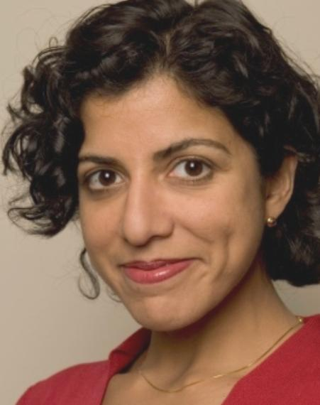 |  | D'Souza  Raissa  Associate Professor  University of California, Davis, USA
Young Scientist | US +1 530/754 8405  raissa@cse.ucdavis.edu  www.ucdavis.edu
An institute at UC Davis which is a multi-disciplinary centre addressing transportation, energy and environmental issues. It has more than 60 affiliated faculty and researchers, 100 graduate students, and a US$ 7 million annual budget.
Personal: 1999, PhD in Statistical Physics; dissertation won Vasquez thesis award; postdoctoral research at Bell Labs and as member of Theory Group, Microsoft Research. Formerly: short-term visiting scientist at Caltech, MSRI, IPAM, UC Berkeley and Ecole Normale Superieure, Lyon, France. Currently: Associate Professor, Complexity Sciences Center; External Professor, Santa Fe Institute; other position. Author of publications on Physics, Computer Science, and Applied Mathematics. Research interests: self-organization, phase transitions and networked interactions occurring in natural and engineered systems.
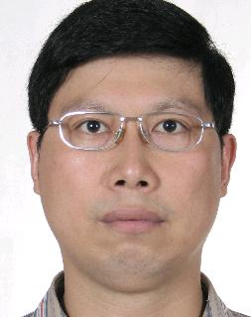 |  | Ding Ke  Professor  Guangzhou Institute of Biomedicine and Health, People's Republic of China
Young Scientist | CN +86 20/3229 0425  +86 20/3229 0485 (fax)  ding_ke@gibh.ac.cn  www.gibh.ac.cn
Personal : 1995, Bachelor's degree and 1998, Master's degree, China Pharmaceutical University; 2001, doctorate in Bioorganic Chemistry, Fudan University; postdoctoral training, University of Michigan. 2005, Research Investigator, Medical School, University of Michigan; with Guangzhou Institute of Biomedicine and Health: 2006, Research Professor; 2008, Deputy Director, research focuses on identification of small molecules as new antitumor or anti-diadetes drugs; successfully designed and synthesized small molecular Bcl-2, MDM2, STAT3 or MMPs inhibitors as new potential anticancer drugs, with some developed into clinical trials. Author of over 30 scientific papers in international journals and key inventor for over 10 patent applications.
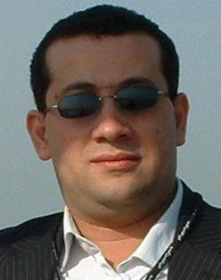 |  | Al Ghouti  Mohammad  Researcher  Royal Scientific Society, Jordan
Young Scientist | JO +962 7/9640 6789  +962 6/534 4806 (fax)  mghouti@rss.gov.jo  www.rss.gov.jo
A not-for-profit institution with financial and administrative independence. It conducts scientific and technological research and development work related to the development process in Jordan with an emphasis on industrial research and services.
Personal: 2004, PhD in Industrial and Environmental Chemistry, Queen's University, Belfast, UK. Since 1997, with Royal Scientific Society and Industrial Chemistry Centre: currently, research scientist and consultant in fuel and lubricants, research focuses on modifying surface of adsorbents and study mechanism and influence on chemical and physical characteristics on adsorption behaviour during adsorption. Member, Editorial Board, International Journal of Information Systems and Social Change. Author of over 25 paper and conference publications published in international journals. Recipient of Jordan Scopus Award, Elsevier, for scientific work (2009).
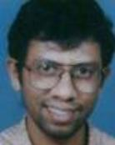 |  | Gopakumar  Rajesh  Professor, Physics  Harish-Chandra Research Institute, India
Young Scientist | IN +91 532/256 7732  gopakumr@hri.res.in
A research institute in India covering theoretical physics and mathematics.
Personal: Undergraduate studies, IIT, Kanpur; PhD, Princeton University; postdoctoral work, Harvard University. Theoretical Physicist whose work is focused on string theory and quantum field theory. With Harish-Chandra Research Institute. National and international awards for research work including: ICTP Prize, Trieste (2006); Fellow, Indian Academy of Sciences (2009).
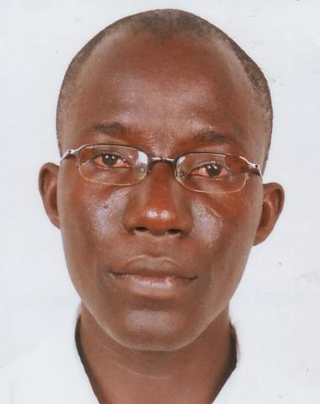 |  | Gueye  Moustapha  Agronomist, Assistant Researcher  Senegalese Agricultural Research Institute, Senegal
Young Scientist | SN +221 33/996 3579  +221 33/996 1152 (fax)  taffaguey@yahoo.fr
A research centre.
Personal: Expertise: Agronomy, plant production, stress physiology, farming systems, soil sciences, agricultural surveys, agricultural experiments, agricultural training and extension.
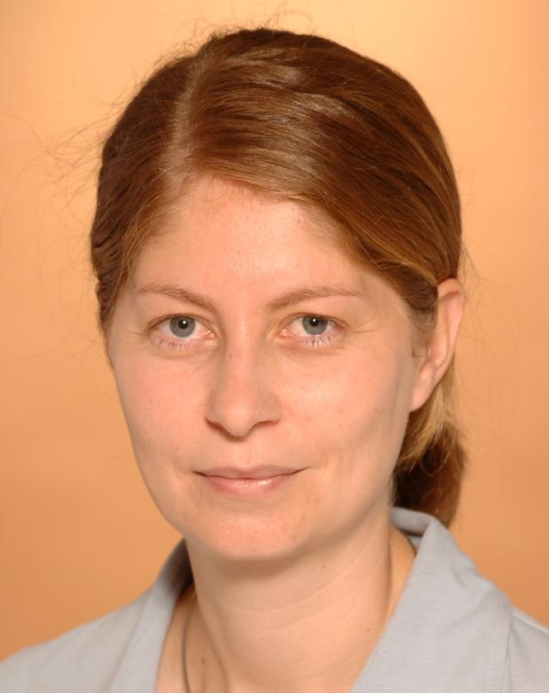 |  | Hanein  Yael  Senior Lecturer  Tel Aviv University, Israel
Young Scientist | IL +972 3/640 7698  +972 3/640 8601 (fax)  hanein@eng.tau.ac.il  www.tau.ac.il
Personal : BSc in Physics, Tel Aviv University, Israel; MSc and PhD in Physics, Weizmann Institute of Science, Israel. 2003, completed four year tenure as research associate in Electrical Engineering and Physics, University of Washington, Seattle; currently, Senior Lecturer, School of Electrical Engineering, Tel Aviv University. Research interests: development of electronic nano devices designed to interface with brain cells and record their activity, understanding brain disorders, the effect of drugs on the brain and the possibility of building implantable electronic brain chips.
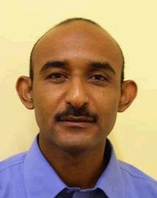 |  | Hassan  Hisham  Secretary-General  Sudanese Academy of Young Scientists, Sudan
Young Scientist | SD +249 91/174 6335  hishamalwazer@hotmail.com
An NGO sponsored by the Sudanese National Academy of Sciences and established in 2007. It aims to promote research and uphold the cause of science in its basic and applied forms for young scientists, raise community awareness about the importance of science and technology in sustainable social, economic and environmental development and award scholarships, prizes and medals in the field of research for Sudanese young scientists. It is involved in activities to popularize science including a bimonthly electronic newsletter.
Personal: Degree, Department of Zoology, Faculty of Science, University of Khartoum; MSc and 2009, PhD in Molecular Biology, Institute of Endemic Diseases, University of Khartoum. Addresses diverse aspects of molecular archaeology and population genetics; carried out study on genetic patterns of Y chromosome and mitochondrial DNA variation. Associate Editor, Editorial Board, Sudanese Academy of Young Scientists newsletter.
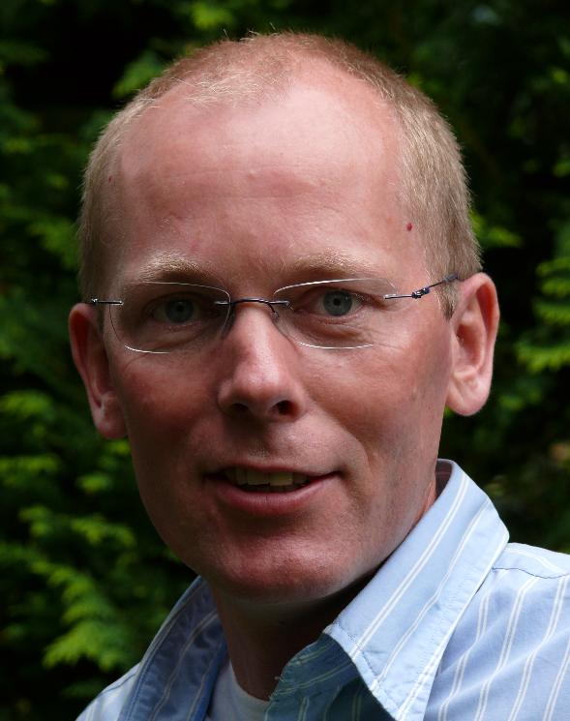 |  | Hilgenkamp  Hans  Professor of Applied Physics and Nanotechnology  University of Twente, Netherlands
Young Scientist | NL +31 53/489 2806  +31 53/489 1099 (fax)  H.Hilgenkamp@utwente.nl  www.utwente.nl
A Dutch university that offers research and degree programmes in technology and in the social and behavioural sciences. It collaborates with TU Delft and TUe Eindhoven under the umbrella of the Netherlands 3TU Federation and is also a partner in the European Network of Innovative Universities. Degree programmes range from business studies and applied physics to biomedical technology and psychology.
Personal: Formerly: with IBM Zurich Research Lab, Switzerland; University of Augsburg, Germany. Visiting Professor, National University of Singapore; 2007, guest scientist, CSIRO, Sydney, Australia. Programme leader, European research programmes. Member of the Board: Applied Superconductivity Conference, US; Young Academy Branch, Royal Dutch Academy of Arts and Sciences. Author of articles in Nature and Science. Recipient of awards, including: Central Education Prize (2007). Research interests: materials with unconventional electronic properties, superconductivity, nanotechnology, new technologies for energy harvesting such as artificial photosynthesis.
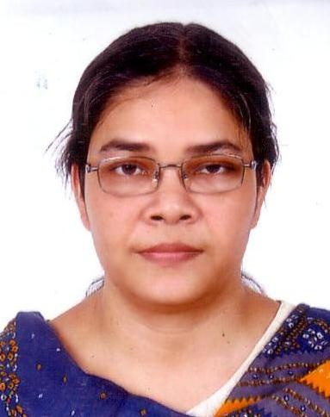 |  | Hoque  Sheikh Manjura  Senior Scientific Officer  Atomic Energy Centre, Dhaka, Bangladesh
Young Scientist | BD +880 02/0862 6603  +880 02/861 7946 (fax)  manjura_hoque@yahoo.com  http://ekh.unep.org
Personal : 1994, BSc in Metallurgy, Bangladesh University of Engineering and Technology; 2000, MSc in Metallurgy, Indian Institute of Science; 2007, doctorate in Nanostructured Magnetic Materials, Bangladesh University of Engineering and Technology. 2001-03, Senior Research Fellow, Materials Science Division, Atomic Energy Centre, Dhaka; 2004, Fellowship Programme, Centre for Materials Science, Natural Science University, National University of Hanoi, funded by International Science Programme, Uppsala University, Sweden and 2005, Solid State Physics, Department of Engineering Science, Uppsala University; conducts research including processing and synthesis, structural characterization and study of magnetic, dielectric and electrical properties of ceramic magnet with the addition, substitution and doping of various elements like rare earth and, or transition, alkaline metal oxides.
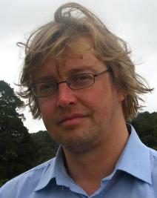 |  | Hutchinson  David  Senior Lecturer  University of Otago, New Zealand
Young Scientist | UK +64 3/479 5102  +64 3/479 0964 (fax)  hutch@physics.otago.ac.nz
Personal : BSc in Mathematics and Physics and PhD in Theoretical Physics, Exeter University; postdoctoral research, Dublin and Canada. Formerly: Lecturer, Somerville College, University of Oxford; since 2000, with University of Otago. Member, Council, Royal Society of New Zealand. Member of the Board, Otago Museum.
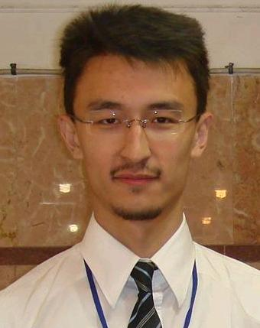 |  | Kapparov  Kassymkhan  Head of Competitiveness Statistics Division  Agency of Statistics of the Republic of Kazakhstan, Kazakhstan
Young Scientist | KZ +7 701/220 9184  +7 717/274 9279 (fax)  kassymkhan@yahoo.com  www.eng.stat.kz
The authorized body that form and realize the state policy in the official statistics area. It was established in 1920 and has strong international connections with Eurostat, CISstat and Statistics office of Norway.
Personal: 2004, BA and 2006, MA in Economics, Kazakh National University; 2007, MBA, Yokohama National University; 2009, LLB, Kazakh Humanitarian Law University. Current responsibilities include managing a group working on the integration of international standards of knowledge economy statistics. Expertise and interests include macroeconomic modeling, statistics and econometrics, influence of R&D on the economic growth and innovations management. Recipient of awards.
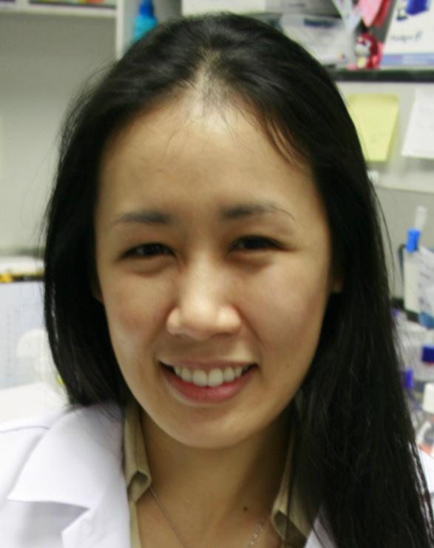 |  | Karoonuthaisiri  Nitsara  Head of Microarray Laboratory  National Center for Genetic Engineering and Biotechnology (BIOTEC), Thailand
Young Scientist | TH +66 2/564 6700  +66 2/564 6705 (fax)  nitsara.kar@biotec.or.th  www.biotec.or.th
An organization first set up under the Thai Ministry for Science, Technology and Energy in 1983. After the establishment of the National Science and Technology Development Agency in 1991, it became one of its centres, operating outside the normal framework of civil service and state enterprises.
Personal: 1999, BSc in Chemical Engineering, Columbia University, US; MSc and PhD in Chemical Engineering, Stanford University, US. Research interests: diagnostic development and high-throughput analysis using micro array as a core platform technology. Author, patent of a use of antibody array to detect multiple food borne pathogens.
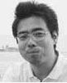 |  | Katayama  Hiroyuki  Associate Professor  The University of Tokyo, Japan
Young Scientist | JP +81 3/5841 6271  +81 3/5841 6271 (fax)  katayama@env.t.u-tokyo.ac.jp  www.u-tokyo.ac.jp
A university, also known as Todai, which was established in 1877 as the first national university in Japan. As a leading research university, it offers courses in essentially all academic disciplines at both undergraduate and graduate levels and conducts research across the full spectrum of academic activity.
Personal: 1991, studied, College of Arts and Sciences, 1993 and 1998, studied, Department of Urban Engineering, University of Tokyo. 1997-98, Research Fellow, Japan Society for Promotion of Science Membership, International Water Association. With University of Tokyo: 1998-2002, Research Associate; 2002, Assistant Professor, Department of Urban Engineering; 2002-04, Assistant Professor, Institute of Environmental Studies, School of Frontier Science; 2004-07, Assistant Professor, Department of Urban Engineering; since 2007, current position. Expertise: water quality and sanitation, water supply engineering, environmental microbiology, environmental leadership development.
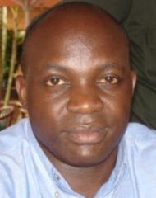 |  | Kirabira  John Baptist  Lecturer  Makerere University, Uganda
Young Scientist | UA +256 77/2422738  +256 41/453 1048 (fax)  jbkirabira@tech.mak.ac.ug  www.mak.ac.ug
One of the oldest universities in Africa, founded in 1922. It has about 35,000 students and aims to play a leading role in the socio-economic transformation of Uganda and neighbouring countries.
Personal: Studies at Makerere University, Uganda; PhD, Royal Institute of Technology, KTH, Sweden. Engineer. Since 1995, Lecturer and Researcher, Makerere University; research mainly in development of products from locally available natural resources. Corporate Member, Uganda Institution of Professional Engineers. Registered Engineer, Engineers' Registration Board, Uganda. Author of publications in materials science and engineering. Expertise: materials science and engineering, product design and development, working with small and medium enterprises helping improve productivity and profitability.
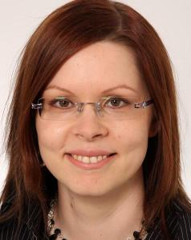 |  | Kivimaa  Paula  Senior Researcher  Finnish Environment Institute (SYKE), Finland
Young Scientist | FI +358 40/526 4216  +358 9/5490 2382 (fax)  paula.kivimaa@ymparisto.fi  http://www.ymparisto.fi/default.asp?node=5297&lan=en
A research institute and a centre for environmental expertise. Its research focuses on changes in the environment and seeks ways to control these changes. Its expertise is based on long-term environmental monitoring, wide-ranging research results, and the institute's highly-qualified staff. The research programmes assess environmental problems from a multi-disciplinary perspective, by integrating socio-economic considerations into scientific research.
Personal: 2000, BSc (Hons) in Environmental Science and Business Management, University of Westminster; 2002, MSc (with Distinction) in Environmental Technology, Imperial College London; 2008, PhD in Organization and Management, Helsinki School of Economics. 2003-08, Researcher, Finnish Environment Institute; 2005, Visiting Researcher, FENIX Research Programme, Stockholm Schools of Economics. Since 2008, current position. Expertise in: innovation and technology research, evaluation of policies, integration of environment, innovation, climate and energy policies, linkages between research and policy. Recipient of the Helsinki School Economics Recognition Award for the highest-quality PhD dissertation in the year 2008..
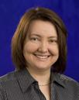 |  | Kovalchuk  Olga  Associate Professor, CIHR Chair in Gender and Health  University of Lethbridge, Canada
Young Scientist | CA +1 403/394 3916  +1 403/329 2242 (fax)  olga.kovalchuk@uleth.ca  www.uleth.ca
Personal : 1992, BMed; 1994, MD; 1998, PhD in Genetics. Chairman, Education and Student Affairs Committee. Member: Environmental Mutagenesis Society, Southern Alberta Cancer Research Institute; Society of Toxicology, Radiation Research Society. Author. Interests: sex differences in radiation responses and carcinogenesis, radiation epigenetics and role of epigenetic changes in genome stability and carcinogenesis, epigenetic regulation of the cancer treatment responses, radiation-induced DNA damage, repair and recombination. Recipient of awards.
Pending update |  | Kruenate  Jittiporn  Researcher  National Metal and Materials Technology Center, Thailand
Young Scientist | TH +66 2/564 6500 ext4445  +66 2/564 6446 (fax)  jittipk@mtec.or.th  www.mtec.or.th
Personal : 1995, BSc in Chemistry, Mahidol University, Thailand; 1997 and 2001, MSc and, PhD in Material Science, UMIST, University of Manchester, UK. Author of patents. Research interests: polymer processing, organic-inorganic hybrids modification, development of bio-based materials. Recipient of awards including, Outstanding Technologist Award, Foundation for the Promotion of Science and Technology under the Patronage of His Majesty the King of Thailand (2008).
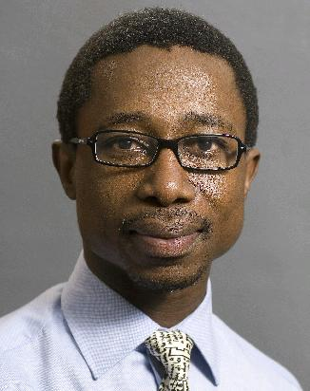 |  | Majozi  Thokozani  Professor  University of Pretoria, South Africa
Young Scientist | ZA +27 12/456 1500  +27 12/633 8729 (fax)  thoko.majozi@up.ac.za  www.up.ac.za
A research university in South Africa which is one of the largest in the country. It celebrated its centenary in 2008.
Personal: PhD, Institute of Science and Technology, University of Manchester, UK. Professor, Department of Chemical Engineering, University of Pretoria. Associate Professor in Computer Science, University of Pannonia, Hungary. Member: European Symposium on Computer Aided Process Engineering; Academy of Sciences of South Africa. Fellow: Water Institution of Southern Africa; CSIR. Member of the Board, Pelchem. Author or Co-Author, over 90 publications in scientific journals and refereed conference proceedings; contributed three chapters in published books. Author, book on Batch Process Integration (winter 2009). Recipient of numerous awards including: Commonwealth Scholarship Award, South African Institution of Chemical Engineers; Chemical Technology Award; Zdenek Burianec Memorial Award, Italy; British Association Medal.
 |  | Mashkina  Olga  Senior Researcher  Finnish Environment Institute (SYKE), Research Programme for Environmental Policy (PTO), Finland
Young Scientist : | Phone: (+358 40) 014 8860  Fax: (+358 20) 490 2391  samartin@dim.uchile.cl
A research institute and a centre for environmental expertise. Its research focuses on changes in the environment and seeks ways to control these changes. Its expertise is based on long-term environmental monitoring, wide-ranging research results, and the institute's highly-qualified staff. The research programmes assess environmental problems from a multi-disciplinary perspective, by integrating socio-economic considerations into scientific research
Personal:
BSc - Economics, 1995
MSc - Environmental economics, 1998
PhD - Economics, 2003.
Finnish Environment Institute (SYKE), Research Programme for Environmental Policy (PTO)

Research of science-policy interface by analyzing the European research funding programmes (ERA-Nets), dissemination and evaluation in research programmes.

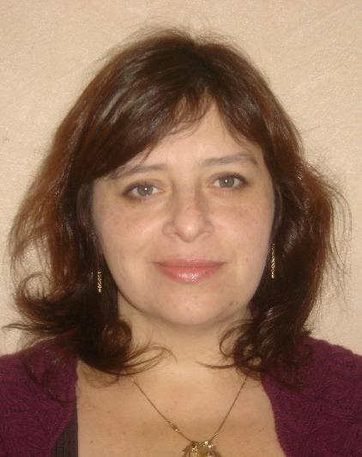 |  | Martínez  Salomé  Associate Professor  Universidad de Chile, Chile
Young Scientist | CL +56 2/978 4667  samartin@dim.uchile.cl  www.dim.uchile.cl
Personal : 1995, degree in Mathematical Engineering, Universidad de Chile; 2000, PhD in Mathematics, University of Minnesota. With Universidad de Chile: 2002, Assistant Professor; since 2008, current position; concurrently Associate Investigator, Centre for Mathematical Modeling. Member, Maths Education Group, Centre for Mathematical Modeling, Universidad de Chile.
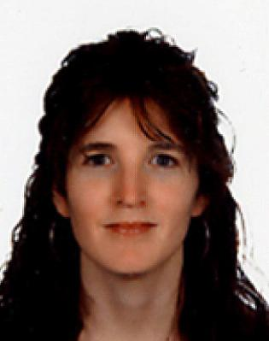 |  | Martinez Aldaya  Maite  Researcher  University of Twente, Netherlands
Young Scientist | ES +31 53/489 4464  +31 53/489 5377 (fax)  M.M.Aldaya@ctw.utwente.nl  www.utwente.nl
A Dutch university that offers research and degree programmes in technology and in the social and behavioural sciences. It collaborates with TU Delft and TUe Eindhoven under the umbrella of the Netherlands 3TU Federation and is also a partner in the European Network of Innovative Universities.
Personal: MSc in Environmental Policy and Regulation, London School of Economics; PhD in Ecology, University of Navarra. Since 2004, with: National Museum of Natural History, Paris; United Nations Food and Agriculture Organization, Rome; Directorate-General, Environment, Soil and Agriculture Unit, European Commission, Brussels. Currently, Researcher on water footprint and virtual-water trade, Twente Water Centre, University of Twente, Netherlands, and collaborator of the Water Observatory of the M. Botin Foundation inSpain. Has written up research on water policies through papers, opinion articles and seminars to help foster better water resource management. Author or Co-Author of 20 articles and book chapters.
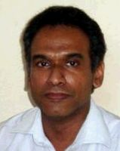 |  | Meegama  Ravinda  Senior Lecturer  University of Sri Jayewardenepura, Sri Lanka
Young Scientist | LK +94 71/8388055  +94 11/2803470 (fax)  rgn@sjp.ac.lk
One of Sri Lanka's most progressive and innovative universities. Located in a serene setting few minutes from the heart of Colombo, the university strives to be a centre for excellence and knowledge by offering a comprehensive range of disciplines ranging from Arts, Management, Science and Medicine at both undergraduate and postgraduate level.
Personal: 1995, BSc (Hons), in Computer Science, University of Colombo, Sri Lanka; 1999, MSc in Computer Science, Asian Institute of Technology, Bangkok; 2004, PhD in Medical Imaging, Nanyang Technological University, Singapore. 1995-96, Project Assistant, National Building Research Organisation, Sri Lanka; 1996-97, Consultant, National Institute of Business Management, Colombo, Sri Lanka; 1998-2004, Lecturer, Centre for Computer Studies, Sabaragamuwa University, Sri Lanka; 2004-08, Senior Lecturer, Centre for Computer Studies, Sabaragamuwa University, Sri Lanka; since November 2008, current position. Former Director: Centre for Computer Studies, Sabaragamuwa University, Sri Lanka; Local Technical Secretariat, World Bank funded IRQUE Project. Member, various organizations and professional bodies.
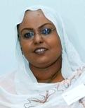 |  | Mohamed  Hiba  Assistant Professor of Molecular Biology  Institute of Endemic Diseases, Sudan
Young Scientist | SD +249 912/605 221  +249 183/779 712 (fax)  hibasalah@iend.org  www.iend.org
An academic institute with the objectives of teaching and training postgraduates, conducting research and offering service to communities by conducting field trips to disease-endemic areas and advancing methods of diagnosis.
Personal: BSc (Hons) in Zoology then 1995-97, MSc in Zoology, University of Khartoum; 1998-2002, PhD in Molecular Biology, University of Khartoum and University of Cambridge, UK. 1999, TDR training fellowship, University of Cambridge; 2004-07, Wellcome Trust Research Development Award; Genetics and functional analysis of SLC11A1 polymorphisms in susceptibility to visceral leishmaniasis in Sudan in collaboration with Professor Blackwell, University of Cambridge, UK; 2007, University of Khartoum research on genetics and immunological factors determining severity of P falciparum infection. Recipient of Royal Society Pfizer Award (2007). Research interests: host-parasite interaction, genetic susceptibility to infectious diseases, in particular to visceral leishmaniasis, post kala-azar dermal leishmaniasis and malaria.
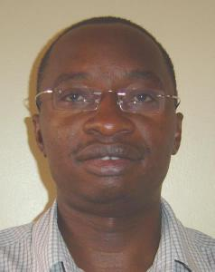 |  | Muyonga  John  Associate Professor  Makerere University, Uganda
Young Scientist | UG +256 41/533 865  +256 41/533 676 (fax)  muyongaj@agric.mak.ac.ug  www.mak.ac.ug
One of the oldest universities in Africa, founded in 1922. It has about 35,000 students and aims to play a leading role in the socio-economic transformation of Uganda and neighbouring countries.
Personal: PhD in Food Science and Technology. Formerly: over 10 years as researcher and lecturer; focus on extraction of value added products from food processing by-products; currently, Head, Food Technology and Business Incubation Programme and current position, Makerere University. Former Member, Institute of Food Technologists, US. Lead consultant and lead researcher, numerous projects. Published in peer reviewed international journals. Member: South African Association of Food Science and Technology; Uganda Institute of Food Scientists and Technologists. Recipient of award, TWAS Young Scientist of the Year (2007).
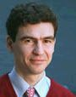 |  | Netea  Mihai  Professor of Experimental Medicine  Radboud University Nijmegen, Netherlands
Young Scientist | NL +31 24/361 4652  +31 24/354 1734 (fax)  m.netea@aig.umcn.nl
One of the seven major Dutch universities. One of the main focuses of the research and development of its University of Medicine is the development of new diagnostic and therapeutic strategies for infections and cancer.
Personal: Studies in Medicine, Iuliu Hatieganu University of Medicine and Pharmacy, Cluj-Napoca, Romania; Doctorate, Radboud University Nijmegen, Netherlands. Member, De Jonge Akademie, Dutch Royal Academy of Sciences. Recipient of awards: Merck Irving S Sigal Memorial Award, American Academy of Microbiology; International Sepsis Forum Young Investigator Award; Dutch Society for Medical Microbiology Aventis Award; Postdoctoral Investigator Award; SmithKline Beecham ICAAC Award; European Society of Clinical Microbiology and Infectious Diseases Young Investigator Award; WRO Goslinsgsprijs, Infectious Diseases Society of the Netherlands; Nijmegen University Centre for Infectious Diseases Award. Expertise: infectious diseases, Immunology, Genetic Anthropology, new diagnostics for infections.
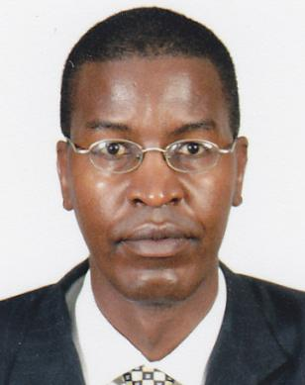 |  | Ngugi  Peter  Senior Lecturer  Daystar University, Kenya
Young Scientist | KE +254 723/979 885  +254 45/224 20 (fax)  ngure2001us@yahoo.com
A private Christian Interdenominational institution whose vision is to train servant leaders for Africa and the world.
Personal: 1991, BSc in Education; 1998, MSc; currently, final year PhD candidate, Institute of Tropical Medicine and Infectious Diseases, Jomo Kenyatta University. Over 12 years' experience teaching at university level; involved in science curriculum development; involved in research in leishmaniasis, HIV, AIDS and Malaria; widely published in peer-reviewed journals. 2009, author of four papers. Recipient, Star of Excellence Award in teaching.
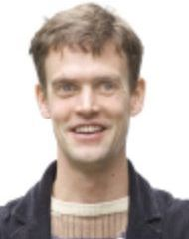 |  | Oosterkamp  Tjerk H.  Scientific Researcher  Leiden University, Netherlands
Young Scientist | NL +31 71/527 5424  +31 71/527 5404 (fax)  oosterkamp@physics.leidenuniv.nl  www.leidenuniv.nl
The oldest university in the Netherlands, founded in 1575, and the first where freedom of belief and religion was practised, as reflected by the university's motto, Praesidium Libertatis. It has approximately 17,000 students and 4,000 staff members.
Personal: 1994, degree in Experimental Physics, Delft University of Technology; 1999, PhD in Experimental Physics, Delft University of Technology. 1999-2000, NATO Fellowship. Since 2000, Assistant Professor, Leiden University, including scanning probe microscopy on biological model systems, development of scanning force microscopes, development of carbon nanotube probes and field emitters; 2004, Co-Founder, Leiden Probe Microscopy. 2009, Member, De Jonge Akademie, the young academy of the Royal Dutch Academy of Sciences. Recipient of Young investigator Award, Human Frontier Science Programme (2002).
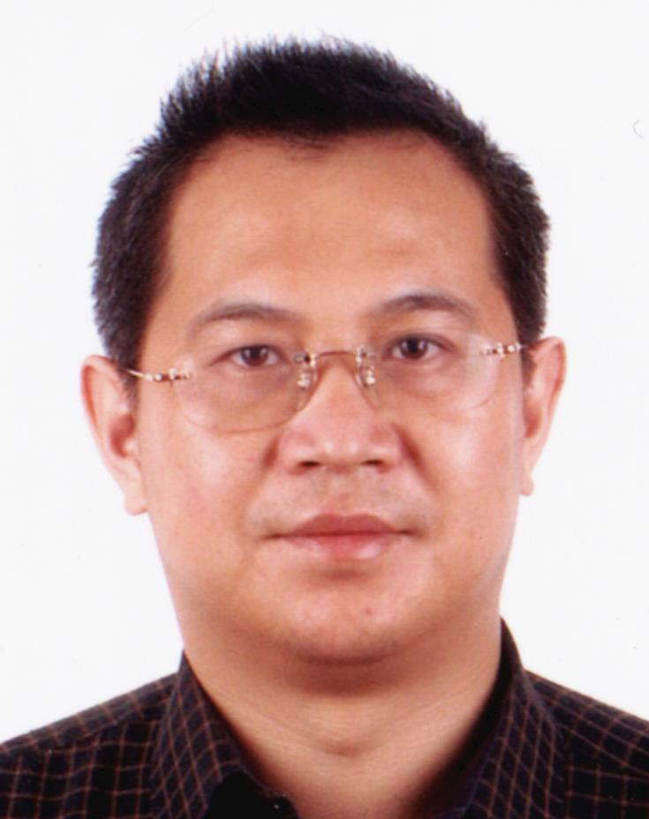 |  | Qin Song  Deputy Director and Professor  Yantai Institute for Sustainable Development of Coastal Zone Chinese Academy of Sciences, People's Republic of China
Young Scientist | CN +86 535/210 8177  +86 535/210 8000 (fax)  sqin@ms.qdio.ac.cn  www.yic.ac.cn
An institute, focused on interdisciplinary research for the sustainable development of coastal zones.
Personal: 1988, BSc in Genetics and Genetic Engineering, Fudan University, China; 1994, PhD in Marine Biology, Chinese Academy of Sciences. With Institute of Oceanology, Chinese Academy of Sciences: 1994, Assistant Research Professor; 1995-97, Associate Research Professor; 1995-96, Guest Research Scientist, Osaka National Research Institute, Japan; 1997, Research Professor; 1999-2000, DAAD fellow, Germany; since 2009, current position. President, Asia-Pacific Society for Applied Phycology. Former President, Asia-Pacific Society of Marine Biotechnology. Council Member and Conference Director, International Marine Biotechnology Association. Council Member, International Society of Applied Phycology.
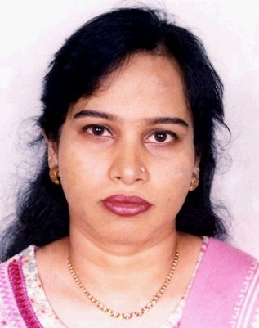 |  | Rahman  Sabita Rezwana  Professor  University of Dhaka, Bangladesh
Young Scientist | BD +8802 /935 1014  sabita_rahman@hotmail.com
The largest state university in Bangladesh with over 80 independent departments.
Personal: Bachelor's and Master's in Microbiology; PhD in Immunology, Strathclyde University, UK. Bachelor's and Master's in Microbiology; PhD in Immunology, Strathclyde University, UK. She contributed to fields of clinical microbiology and immunology by developing rapid diagnosis of Shigella using monoclonal antibody both in ELISA and Chemioluminescence technique. Her present research interest is in undertstanding in multidrugresistance pattern of bacteri, role of indeginous plants in controlling growth and pathogenesis of MDR bacteria. She has over 46 publications in reputed national and intertanional journals. Served thirteen years with Department of Microbiology, University of Dhaka. Interests: cooking, oil painting. Recipient of awards.
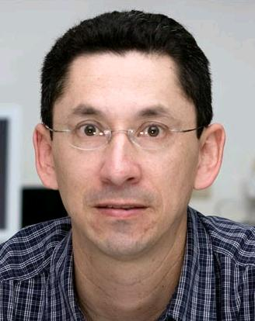 |  | Ron  Santiago  Professor  Pontificia Universidad Católica del Ecuador, Ecuador
Young Scientist | EC +59 32/2991700 Ext. 1981  santiago.r.ron@gmail.com  http://www.puce.edu.ec/zoologia/introduccion.html
The largest animal natural history collection and a leading institution in studies of biodiversity in Ecuador.
Personal: 1998, MA, University of Kansas; 2007, PhD, University of Texas, Austin. Currently, Full Professor, Pontifical Catholic University of Ecuador, Quito and Curator, Herpetology, Museum of Zoology. 2007, Chair for Ecuador, Amphibian Specialist Group, World Conservation Union; 2008, Affiliate Member, Academy of Sciences for the Developing World. Has contributed to fields of systematics and behaviour of Neotropical amphibians; using a phylogenetic framework, has analyzed evolution of female's preferences for complex courtship traits; has examined how sexual selection has interplayed with morphological constrains to shape evolution of male courtship traits; has studied global phenomenon of amphibian population declines. Research interests: evolution and conservation.
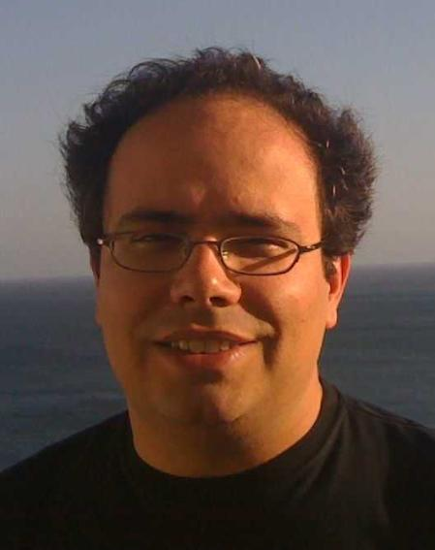 |  | Silva  Luis  Associate Professor  Instituto Superior Tecnico, Universidade Tecnica de Lisboa, Portugal
Young Scientist | PT +351 218/419 336  +351 218/464 455 (fax)  luis.silva@ist.utl.pt  www.ist.utl.pt
An institute, founded in 1911, which is the largest school of engineering in Portugal. It has two campuses, at Alameda in Lisbon and Taguspark in Oeiras, with 8,500 undergraduate and over 1,500 graduate students Its faculty members include over 700 Professors and interdisciplinary scientific activities are developed in about 30 different research units.
Personal: 1992, MSc in Physics Engineering and 1997, PhD in Physics, Instituto Superior Técnico, Portugal. Since 2005, current position. Member: European Physics Society; American Physical Society. Expertise/Interests: advanced particle accelerators and light sources for bio medical applications, relativistic astrophysics and high performance computing, early music, modern literature, contemporary art, squash, basketball, outreach and mentoring activities to promote the vision of science. Recipient of awards.
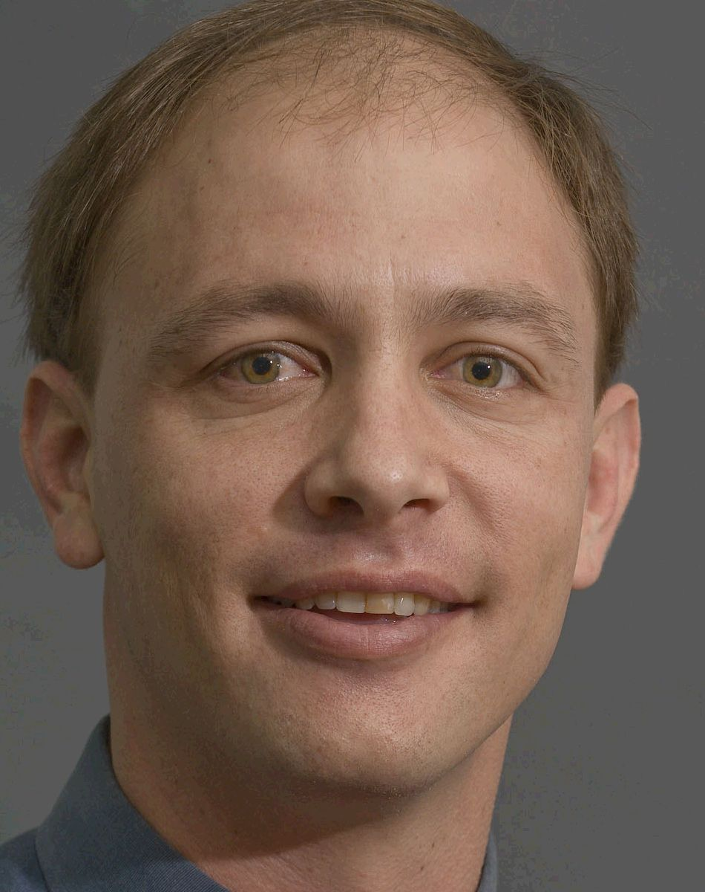 |  | Slippers  Bernard  Associate Professor  University of Pretoria, South Africa
Young Scientist | ZA +27 12/420 2463  +27 12/420 3960 (fax)  bernard.slippers@fabi.up.ac.za  www.up.ac.za
A research university in South Africa which is one of the largest in the country. It celebrated its centenary in 2008.
Personal: PhD, University of Pretoria; postdoctoral Fellow, Swedish University of Agriculture, Uppsala. Currently: Associate Professor in Genetics. University of Pretoria; Research Leader, Tree Protection Co-operative Programme and Centre of Excellence in Tree Health Biotechnology, Forestry and Agricultural Biotechnology Institute; research focus on molecular ecology and evolution of insects and micro-organisms that affect tree health, and anthropogenic influences on it; advises governmental and private organizations on tree protection issues in South Africa, Indonesia, Europe and the US. Author of over 50 papers in international peer-reviewed journals. Recipient of numerous awards including: International Union of Forestry Research Organizations, for outstanding doctoral research; Presidents Award, National Research Foundation in South Africa.
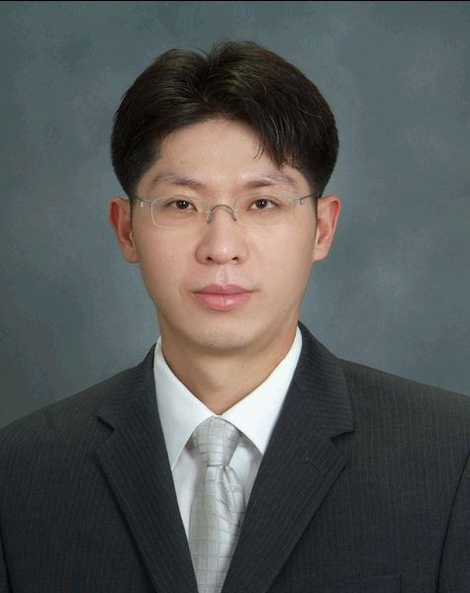 |  | Sohn Hoon  Associate Professor  Korea Advanced Institute of Science and Technology (KAIST), Republic of Korea
Young Scientist | KR +82 42/350 3625  +82 42/350 2210 (fax)  hoonsohn@kaist.ac.kr  www.kaist.ac.kr
An institute which has been ranked as the top university in Asia by Asiaweek.
Personal: 1992, BSc and 1994, MSc in Civil Engineering, Seoul National University; 1999, PhD in Structural Engineering, Stanford University. Since 1999, Partner and Chief Scientist, Los Alamos Dynamics; 2001-2004, Technical Staff Member, Weapon Response Group, Los Alamos National Laboratory; 2004-2006, Assistant Professor, Department of Civil and Environmental Engineering, Carnegie Mellon University; since 2007, Associate Professor, Department of Civil and Environmental Engineering, KAIST, South Korea; Adjunct Professor, Department of Civil and Environmental Engineering, Carnegie Mellon University. Research interests: structural health monitoring and damage detection, smart materials and structures, active sensing, experimental modal analysis and vibration testing, system identification, signal processing, probabilistic and statistical analysis, statistical pattern recognition, structural analysis, structural dynamics.

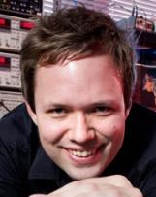 |  | Sutherland  Michael  Royal Society University Research Fellow  University of Cambridge, United Kingdom
Young Scientist | UK +44 1223/337 389  +44 1223/334 678 (fax)  mls41@cam.ac.uk  www.cam.ac.uk
A major UK university and research institution.
Personal: 2004, PhD in Physics, University of Toronto; postdoctoral fellowship, National Science and Engineering Research Council of Canada, University of Cambridge. Scientist working experimental condensed matter physics; research is focused on understanding electronic properties of correlated electron materials including superconductors, novel magnets and quantum critical systems. Currently, runs research group, Cavendish Laboratory, Cambridge. Fellow, acting Dean and Director of Studies in Physics, Corpus Christi College. Expertise: experimental measurements of electrical and thermal transport at ultra-low temperatures and high magnetic fields. Interests: science and education policy, particularly those related to innovation.
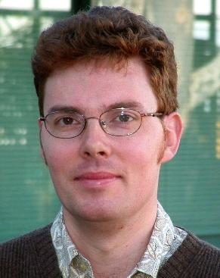 |  | Tickner  James  Stream Leader  Commonwealth Scientific and Industrial Research Organisation (CSIRO), Australia
Young Scientist | AU +61 8/8303 8430  +61 2/9710 6789 (fax)  james.tickner@csiro.au  www.csiro.au
Australia's national science agency and one of the largest and most diverse research agencies in the world.
Personal: Degree in Physics, University of Oxford, UK; doctorate in Particle Physics, working on ZEUS experiment in Hamburg, Germany, looking at structure of proton. Since 1998, with CSIRO, developing radiation-based measurement and imaging systems for minerals and security applications; developed new air cargo scanner than combines neutron and X-ray imaging to identify contraband materials in bulk air freight; currently, heads Security Technologies research stream and Nucleonics research group combining scientific innovation, project and team leadership and research commercialisation activities.
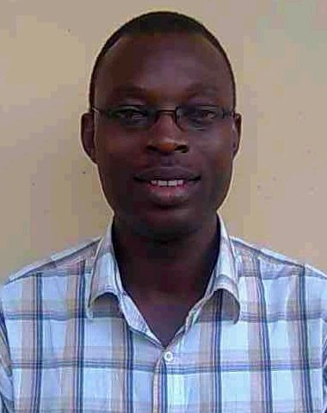 |  | Unuabonah  Emmanuel  Lecturer  Redeemer's University, Nigeria
Young Scientist | NG +234 805/3175971  iyaemma@yahoo.com  www.run.edu.ng
A university which aims to raise role models that will transform society and academics with independent and original research that will have a direct and positive impact on the world.
Personal: 1999, BSc in Industrial Chemistry; 2003, MSc in Industrial Chemistry, 2007, PhD in Industrial Chemistry. 2001, National Service with Federal College of Education; postgraduate research fellow, TWAS-CAS, currently, postdoctoral fellow, DST-NRF Centre of Excellence in Strong Materials, University of Witwatersrand, Johannesburg. Member: International Adsorption Society; Chemical Society of Nigeria. Research interests: modification of phyllosilicate minerals for use in adsorption of metal ions and organics, utilization of other low cost adsorbents for adsorption of metal ions and organics, preparation, characterization and utilization of novel mesoporous nano materials.
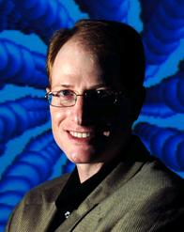 |  | Weiss  Gregory  Associate Professor  University of California, Irvine, USA
Young Scientist | US +1 949/824 5566  +1 949/824 9920 (fax)  gweiss@uci.edu  www.uci.edu
A California university, founded in 1965, that is a major research centre. It has more than 27,000 students, nearly 2,000 faculty members and 8,900 staff.
Personal: 1992, BSc in Chemistry, University College Berkeley, US; 1997, PhD, Harvard University, US. 2000, joined University of California, Irvine; laboratory research consists of anticipating the development of anti-viral drug resistance by multi-dimensional molecular evolution, dissecting and controlling function of membrane-associated proteins, wiring viruses into electronic circuits, and directly watching single molecules with nanometer-scale electronics; since 2006, current position. Scientific consultant to numerous government panels and companies. Recipient of awards.
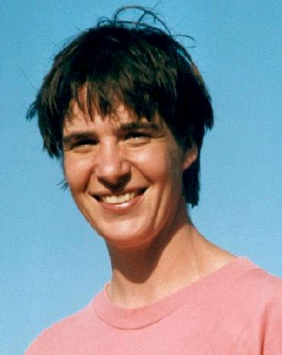 |  | Weyhenmeyer  Gesa  Lecturer  Uppsala University, Sweden
Young Scientist | DE +46 18 471 2711  Fax +46-18 4710705  Gesa.Weyhenmeyer@ebc.uu.se  http://www.uu.se
A university, founded in 1477, with world-class research, education, tradition and culture. Its focus is on sustainable environment and technology, global survival, human health and advancement of culture and society.
Personal: In Sep 2008 appointed as Professor (Chair) of Water Quality Management at the Swedish University of Agricultural Sciences; position not started due to offer at Uppsala University where I began in May 2009. Since May 2003 Associate Professor of Aquatic Ecology. Oct 1996: Doctor of Philosophy (PhD), Uppsala University, Sweden. May 1992: Bachelor of Science, Trent University, Canada. Selected distinctions: 1. Awarded by the Chancellor of SLU to the leadership education: Tomorrows academic leaders in 2008, 2. Awarded to the mystery session of the American Society of Limnology and Oceanography (one of the “most innovative, integrative, and exciting abstracts to create stimulating pairings and groupings that address overarching themes of broad interest to limnologists and oceanographers”) in 2007, 3. Awarded to a 5-year Research Fellow Post at the Royal Academy of Sciences in 2005. Expertise and interests: Global change impacts on freshwaters (professional); music and outdoor activities.
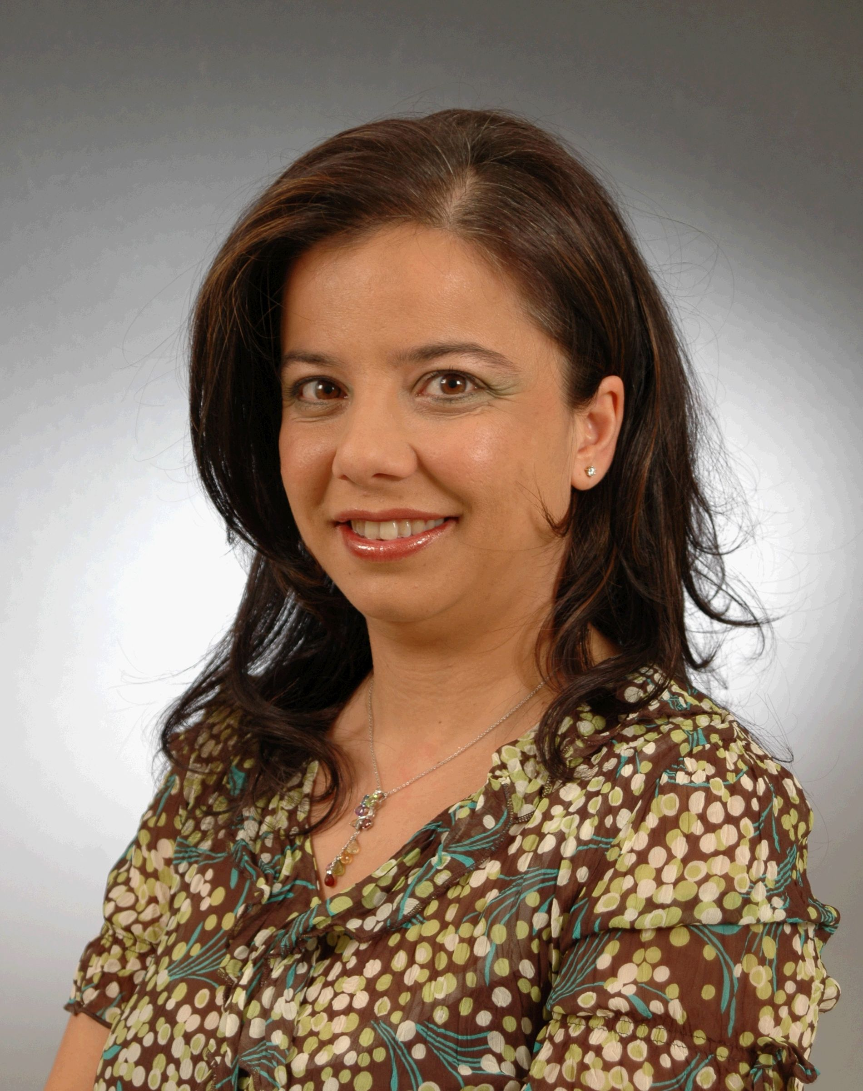 |  | Yetis  Bahar  Associate Professor  Bilkent University, Turkey
Young Scientist | TR +90 312/290 3156  +90 312/266 4054 (fax)  bkara@bilkent.edu.tr  www.bilkent.edu.tr
Personal : 1992, BA, 1994, MSc and 1999, PhD, Industrial Engineering Department, Bilkent University, Ankara. 1999-2000, post-doctoral Research Fellow, Faculty of Management, McGill University, Canada. With Department of Industrial Engineering, Bilkent University: 1992-99, Teaching and Research Assistant; 2001, Instructor; 2001-06, Assistant Professor; since 2006, current position. 2004, Associate Professor, Higher Educational Council of Turkey. Research interests: hub location, hazardous materials logistics, healthcare logistics, vehicle routing problems, network design.

8/10/2009/IAP

